Matt Brothen Unit1 Apply

9/12/18

Question 5

* mySchoolPlayground
  + playPlaces
  + publicParks
  + cityLots
* shrimpAlfredo
  + pastaDishes
  + shrimpMeals
  + recipes
* grandmasRockingChair
  + furniture
  + woodworkingPlans
  + chairs

Question 6

MovieQuote.java

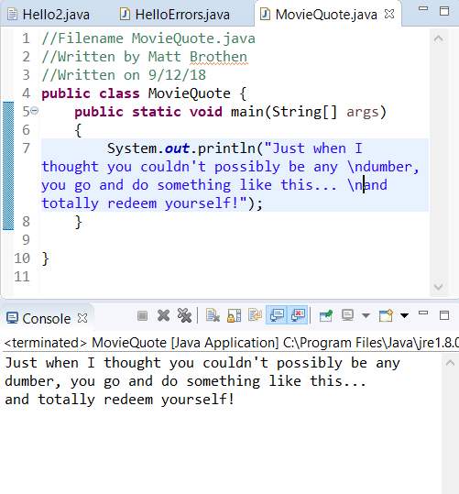

MovieQuoteInfo.java

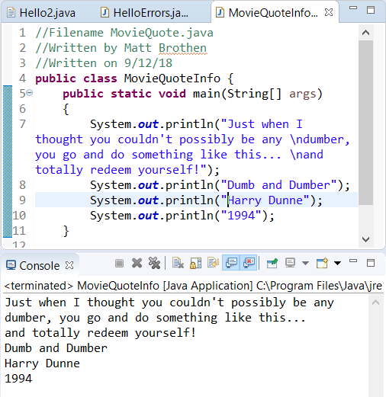

TableAndChairs.java

I found it easier to design the table and chairs in their own file and copy and paste each line into the out statement.

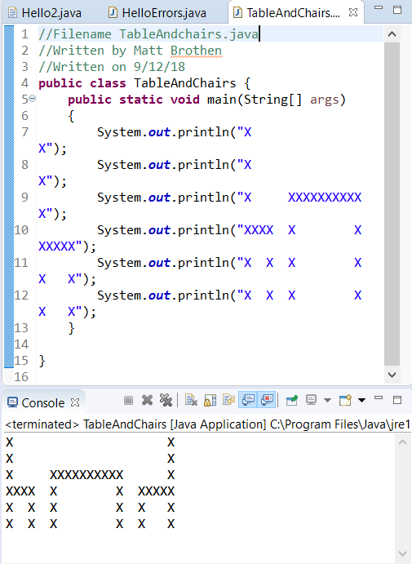

FavoriteSong.java

No this is not my favorite song.

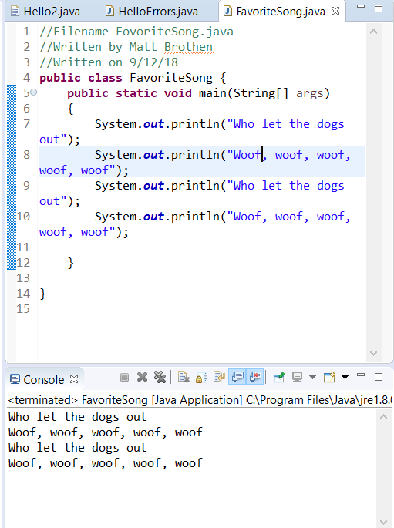

Comments.java

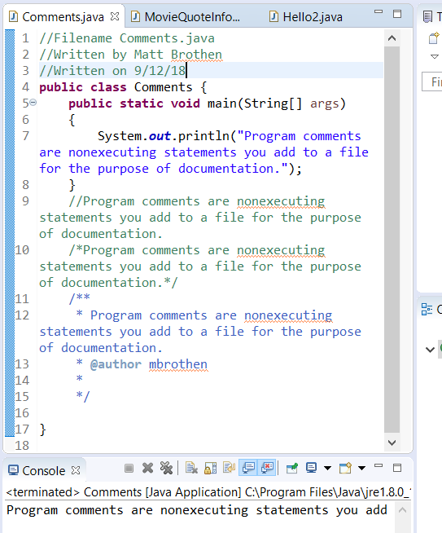

CommentsDialog.java

